AMBITION HEALTH LOKSEWA CENTER
☎9845610294 Website: dilipkyadav.com.np
PHYSIOLOGY
ENDOCRINE SYSTEM
ANATOMY

- The endocrine system is a complex network of glands and organs. It uses hormones to control and coordinate your body's﻿metabolism, energy level, reproduction, growth and development, and response to injury, stress, and mood.
- Nervous system is the first and endocrine system is second greater control system of body.
- It is constitutes endocrine gland, which are situated in different part of body and maintain homeostatic condition of internal environment of body.
- Endocrine glands of body are:
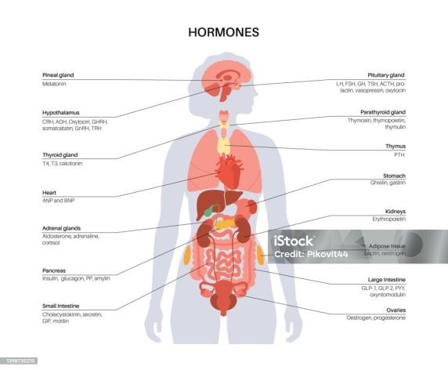
- Hypothalamus
- Pituitary gland
- Thyroid
- Parathyroid
- Thymus gland
- Adrenal gland
- Pancreas
- Testes & Ovaries (Gonads)

Hypothalamus:
→ It is called (super-master gland):- It control anterior and posterior lob of pituitary gland.
Secretes hormones are:
- GHRH:- Growth hormone releasing hormone
- GHIH:- Growth hormone inhibiting hormone
- PRH:- Prolactin releasing hormone
- PIH:- Prolactin inhibiting hormone
- TRH:- Thyroid releasing hormone
- CRH:- Corticotrophin releasing hormone
- LHRH:- Luteinizing hormone releasing hormone
- GnRH:- Gonadotrophin releasing hormone
- Functions: Affect sexual activity & sleep, emotion and endocrine, thirst, Temperature regulation:-Sleep and awake pattern, Biological clock.
2. Pituitary gland (Hypophysis cerebri)
It is smallest Master gland. It is situated in sphenoid bone in hypophysial fossa (sella turcica). Weight is 500mg.
Pituitary Gland-----------------3 Lobe ------anterior lobe -----posterior lobe ----------------middle lobe

PITUITARY GLAND ----------------------ANTERIOR LOBE ------------------------------HORMONES ---------------
1) Growth Hormone (GH):-
→ GH acts on all tissue. GH hormone कम भएमा simmond's disease र बढ़ी भएमा Gigantism, and in adult → Acromegaly हुन्छ। Stimulates Pancreas to produce somatostatin .
2) Thyroid Stimulating Hormone (TSH):-
- Stimulates thyroid gland to produce thyroid hormone – T4(Thyroxine) , T3(Tri-iodithyronine)
Adrenocorticotropic Hormone (ACTH):-
- Produced by :- Anterior lobe of pituitary gland
- Target organ :- Adrenal cortex
- Acts on adrenal cortex. Stimulates adrenal cortex to secrete cortisol (glucocorticoids) by adrenal , lesser extent aldosterone and androgens
- Trigger by :- CRH ( Corticotrophin hormone) from the hypothalamus
Prolactin hormone (Lactogenic) (PRL):-
- Produced by :- Anterior lobe of pituitary gland
- Target organ :- Mammary glands
- Main functions: - Stimulate milk production( lactation) after child brith.
- Regulation :- Stimulated:- by suckling , ( TRH-Thyrotrophin releasing hormone , stress , Inhibited :- by – Dopamine ( also called prolactin inhibitory hormone or PIH)
- Prolactin hormone also play a part in immune regulation and reproductive health
Gonadotrophic Hormone (GnH):-
It is 2 types.
i) Follicle Stimulating Hormone (FSH):-
- Produced by : anterior pituitary gland
- Stimulated by :- GnRH (Gonadotrophin releasing Hormone) from Hypothalamus
- Inhibited by :- inhibin and estrogen / testosterone
FUNCTION :-
Male | Female
Stimulates spermatogenesis from semniferrous tubules  - Act on sertoli cell in the testes to support the sperm development. | - Stimulates the growth of ovarian follicles  - Promote estrogen secretion from granullosa cell

ii) Luteinizing Hormone (LH):-
- Produced by : anterior pituitary gland
- Stimulated by :- GnRH(Gonadotrophin releasing Hormone) from Hypothalamus
FUNCTION :-
Male | Female
- Testosterone production : Leydig cell of Testes  - Sperm production  - Development of secondary sexual character | - Release of mature egg from ovary ( ovulation)  - Formation of corpus luteum  - Corpus luteum→progesterone ( prepare uterus  - LH works with FSH →Ovary →produce →estrogen

B. Posterior lobe (Neurohypophysis):-
- It stores and releases hormone from hypothalamus.
i) Oxytocin:-
- It helps in ejaculation of milk & contraction of uterus.
- Known as “Love Hormone” or bonding hormone
- Synthesized or produced by → Hypothalamus
- Store and released by → Posterior lobe of Pituitary gland
ii) Antidiuretic Hormone (ADH)
- Also known as Vasopressin.
- Synthesized in Hypothalamus.
- Store/secreted/release by posterior pituitary gland.
- Main function: - water reabsorption from kidney, to maintain body fluid balance and blood pressure.
- Target site:- collecting duct of Nephron
- ADH associated disorder: DI(Diabetes insipudus) :- [ Central DI ↓ ADH ] , [Nephrogenic DI : Kidney unresponsive to ADH.]

C. Middle (intermediate) Lobe:-
- It produce Melanocyte stimulating hormone (determine color of body).
- It stimulates melanin synthesis.
- In human, it is smaller and less functional.
3. Thyroid gland:-
- It is the largest endocrine gland. Its wt. 25gm (20-30gm), located at C5 to T1.
- It produce T3 (tri-iodothyronine), T4 (thyroxine) & Calcitonin.
- T3 & T4 secreted by → Follicullar cell and calcitonic secreted by →parafollicullar cell
- Iodine is required for formation of thyroid hormones
- 2 Lobes – Right and left ( 5 cm long 3 cm wide)
Functions:-
- Protein, Carbohydrates & fats metabolism, mental development, maintain basal metabolic rate.
- Increase body's growth & Thermogenesis and helps in Calcium & Phosphorus homeostasis (in adult).
- Function of T3 & T4 is similar.
- Calcitonin decreases the level of calcium and phosphates out of blood.
- Increase level of thyroid hormone – Hyperthyroidism or thyrotoxicosis
- Hyperthyroidism includes :- Graves disease : Most common type of Hyperthyroidism ( 75) % which is autoimmune cause.
- Toxic nodular goiter
- Adenoma ( Benign tumor)
- Decrease level of Thyroid hormone : Hypothyroidism includes : simple goiter , Cretinism ( child ) , Myxoedema ( adult)
- Thyroidectomy : surgical removal of thyroid gland . Thyroid disorder mc in Female than Male .
PARATHYROID GLAND
- Location : posterior part of thyroid gland. 4 in number . weight : 50 mg , secrete hormone : Parathyroid hormone or parathormone ( PTH )
- Function of PTH : - Regulate serum calcium level through it’s effect on bone , kidney and intestine.
ADRENAL GLAND

- Also known as suprarenal gland, emergency gland or 4s gland.
- Sugar retention sugar metabolism sexual function and safety
- 4 cm long and 3 cm thick.
- 2 parts : 1) cortex -80% 2) Medulla 20%
Hormone of Adrenal cortex and medulla and their function
Adrenal cortex hormone | Function | Adrenal medulla hormone | Function
- Mineralocorticoids  Eg-Aldosterone | - Salt regulation  - Maintaining water and electrolyte balance | - Adrenaline ( epinephrine) – 80% | - Adrenaline and nor a adrenaline are neuro transmitters –they stimulates sympathetic nervous system to regulate Fight or Flight responces
- Cortisol ( hydrocortisone) | - Regulating sugar metabolism  - Response to stress  - Can be given through | - Nor adrenaline ( nor epinephrine) – 20%
- Sex hormones
Androgen

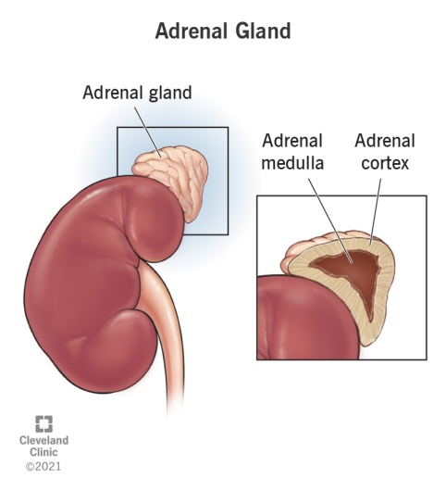
ADRENAL CORTEX
Zona Glomerulosa – Salt → Aldosterone
Zona Fasciculata – Sugar → Cortisol
Zona Reticularis – Sex → Androgens
Adrenal medulla:
Think "MEN" for Medulla:
M – Medulla
E – Epinephrine (Adrenaline)
N – Norepinephrine (Noradrenaline)

Pancreas (Islets of Langerhans)
Endocrine portion of pancreas.
- Alpha (α) cells: Secrete glucagon (raises blood sugar).
- Beta (β) cells: Secrete insulin (lowers blood sugar).
- Delta (δ) cells: Secrete GHRH (Growth Hormone Releasing Hormone).
- F cells: Secrete pancreatic polypeptide.
Thymus Gland
- Located behind the sternum in the chest.
- Two lobes; enclosed by areolar tissue.
- Secretes thymosin.
- Helps in T-lymphocyte maturation.
- Weight: 10–15g at birth → grows until puberty (30–40g).
- After puberty: atrophies (shrinks).
- By middle age: Returns to birth size.
Pineal Gland
- Also called brain sand.
- Located on the roof of the third ventricle.
- Size: About 10 mm, reddish-brown.
- Secretes melatonin.
- Regulates sleep cycle and circadian rhythm.
- Melatonin level: High at night, low in daylight.
- Influences puberty.
Hormonal Disorders
Growth hormone deficiency: Dwarfism.
Growth hormone excess:
In children: Gigantism.
In adults: Acromegaly.
Insulin deficiency: Diabetes mellitus.
ADH deficiency: Diabetes insipidus.
Thyroid hormone deficiency:
In children: Cretinism.
In adults: Myxedema.
Thyroid hormone excess: Hyperthyroidism, Graves’ disease.
Subjective questions :-
Great! Below are 5 written-based subjective questions from the Endocrine System, each designed to be worth 5 marks. These questions test conceptual understanding, not just fact recall.

Q1.
Describe the structure and function of the adrenal gland. Name the hormones secreted by each part.
(Include both adrenal cortex and medulla, and explain the function of at least 3 hormones.)

Q2.
What is the role of the thyroid gland in metabolism? Explain how T3 and T4 hormones regulate metabolic rate.
(Include feedback mechanism with the hypothalamus and pituitary gland.)

Q3.
Compare and contrast the roles of insulin and glucagon in blood glucose regulation.
(Include their source, target organs, and effect on glucose levels.)

Q4.
Explain the negative feedback mechanism involved in the regulation of cortisol secretion.
(Draw or describe the HPA axis: Hypothalamus–Pituitary–Adrenal relationship.)

Q5.
List any three major endocrine glands and describe one hormone from each along with its function.
(E.g., pituitary, pancreas, thyroid – choose hormones like GH, insulin, T3/T4, etc.)

